IMAP² JUNE 2007 INSTITUTE
DPGRAPH-DYNAMIC GEOMETRY
HOW TO NOTES BY WS

This document is stored at the url below

http://www.math.uiowa.edu/~wseaman/IMAP%5e2/June2007/DP-DynGeome-HowToIntro-061707.htm

PART 1 THREE-DIMENSIONAL GEOMETRY

We are going to use a program called DPGraph (Dynamic Photorealistic Graphing) to look at some three-dimensional geometry questions. We will be able to take cubes, pyramids, etc. and see what we get by slicing those shapes with two-dimensional planes.

Follow the workshop presenter's instructions to open the DPGraph file called PlaneSliceCubeCornerPlane060107.dpg. You will see the graphic shown below. Next steps are written below the graphic and will be detailed by the workshop presenter.

PlaneSliceCubeCornerPlane060107.dpg

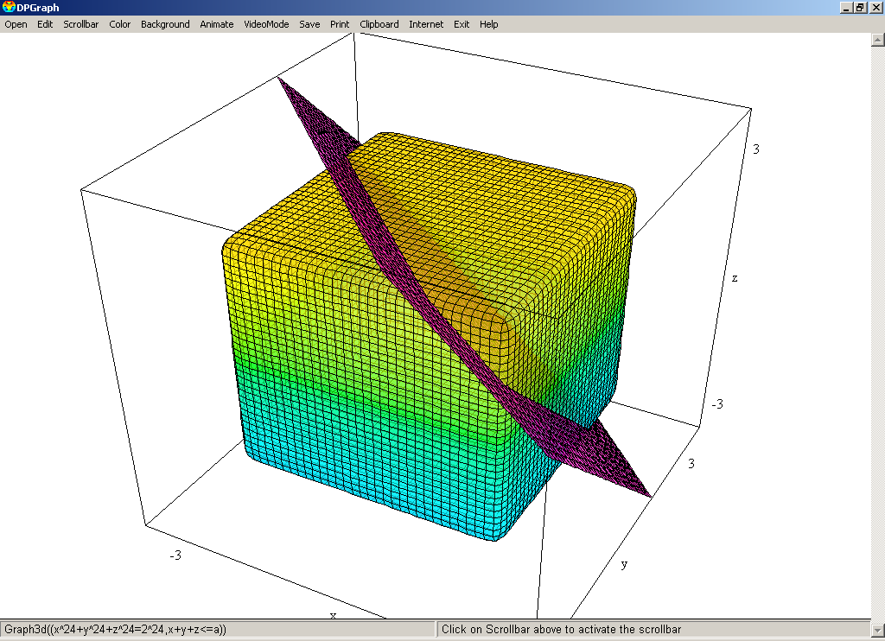

Instructions for how to view this geometric picture from different perspectives and manipulate it are given in the box below.

To rotate this picture in three-space so as to view it from different perspectives,

use the keyboard ARROW KEYS (to the right of the QWERTY part of the keyboard)

← (clockwise rotation about z-axis)

→ (counter clockwise rotation about z-axis)

(rotation 'top to bottom' one way)

↓ (rotation 'top to bottom' the opposite way)

Use the keyboard buttons

Page Down to zoom OUT

Page Up to zoom IN

To see slices of the cube with moving planes choose from the MENU BAR
SCROLLBAR
then click the A VARIABLE
then click OK

Now move the scrollbar at the RIGHT SIDE of the window up or down.
You should see the plane move and create different slices.
Want to modify some of the picture in another way? Open the Edit menu to reveal the commands which create these graphics.

Questions:
Q1. -Cube slices

What kind of plane shapes or slices do you get if you use a different plane from the one in the above graphic?

For example, what kind of plane shapes or slices do you get if suppose you take a plane parallel to one of the faces of the boundary box (a 'coordinate plane')?
Open the file: PlaneSliceCubeCoordPlane060107.dpg

What kind of plane shapes or slices do you get if suppose you take a plane that contains the 45-degree line in the xy-plane?
Open the file: PlaneSliceCube45DgrXYPlane060607.dpg

When you slice the cube with a plane, the resulting picture in that plane can be many different shapes depending on what plane you used and how that plane slices the cube. Depending on which plane you start with, some of the possible plane slices of the cube you can get are:

A point,
A triangle,
A rectangle,
A square
and a hexagon

Can you ever get a pentagon? How about an octagon? Can you ever get a curved slice, like a circle?
Open the file: PlaneSliceSqrCubeCornerPlaneABOVE060507.dpg

Q2. -Pyramid slices

Suppose we replace the cube with a pyramid. Investigate the same types of questions as in Q1, when you replace the cube with a pyramid.

Open the file PlaneSlicePyramidCornerPlane060107.dpg

What kind of plane shapes or slices do you get if you use a different plane from the one in this file? What kind of plane slices can you get? Are there some plane figures which will never occur (no matter what slice plane you pick?).

Q3. -Tetrahedron slices

Suppose we replace the cube with a tetrahedron. Investigate the same types of questions as in Q1, when you replace the cube with a tetrahedron.

Open the file PlaneSliceTetrahedronZCoordPlane060507.dpg

What kind of plane shapes or slices do you get if you use a different plane from the one in this file? What kind of plane slices can you get? Are there some plane figures which will never occur (no matter what slice plane you pick?).

Open the file PlaneSliceTetrahedronXZPlaneCutOff060507.dpg

Availability of DPGraph:
All University of Iowa faculty, staff, and students may download this program for free
on any computer they use. It runs only on PCs.
Go to the url
www.dpgraph.com
Click on List of Site Licenses, click on U to find UI link and download at this url:
http://www.dpgraph.com/graphing-users.html#U

PART 2 TWO-DIMENSIONAL GEOMETRY

CPMPTOOLS

This free software can be downloaded by clicking on the following Western Michigan University url

http://www.wmich.edu/cpmp/applets/CPMP-Tools.jnlp

This site should allow you to download the CPMPTools file.
You might see a window prompting you to run the program such as the one below.

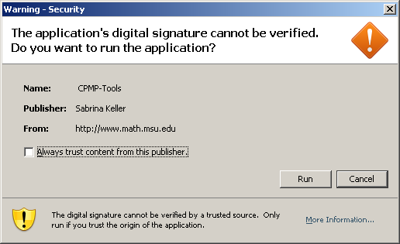

Click on the Run button. Once the program loads, you will see the screen below.

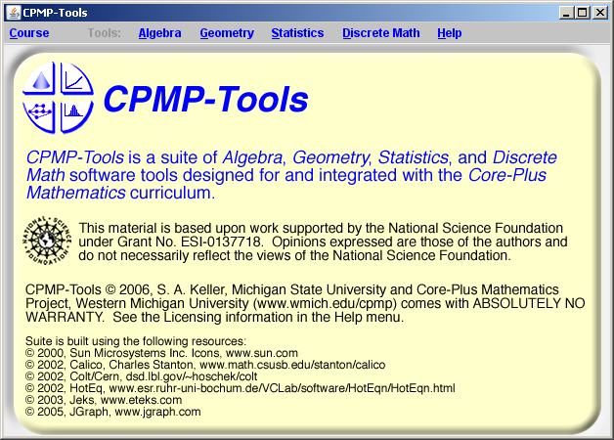

Although it was designed to support parts of the Core Plus Mathematics Curriculum, its algebra, geometry, statistics and discrete math can be used without any connection to CPMP. You may also visit the official site for CPMPTools www.wmich.edu/cpmp/CPMP-Tools for supplement resources (additional sketches, alternative investigations, etc).

We will be using the geometry program to work with triangles and other plane figures. We will use the software to apply distance-preserving transformations to the plane figures. These transformations are also sometimes called rigid motions, congruences, isometries, symmetries and other names. The totality of such transformations consists of reflections across lines, rotations, translations and glide reflections.

If you have used a dynamic geometry program like Geometer's Sketchpad or Cabri, the CPMPTools Geometry computer set up may look familiar.

PART 2 -POLYA'S PROBLEM-SQUARES IN TRIANGLES

Follow the workshop presenter's instructions to open the CPMPTools file called PolyaProblem19-IMAPP-061607pm.txt

(through the Geometry/CoordinateGeometry/File/Open menus). You will see the graphic shown below. Descriptions and questions appear in the graphic and will be detailed by the workshop presenter. Questions are also posed in the graphic which we will investigate.

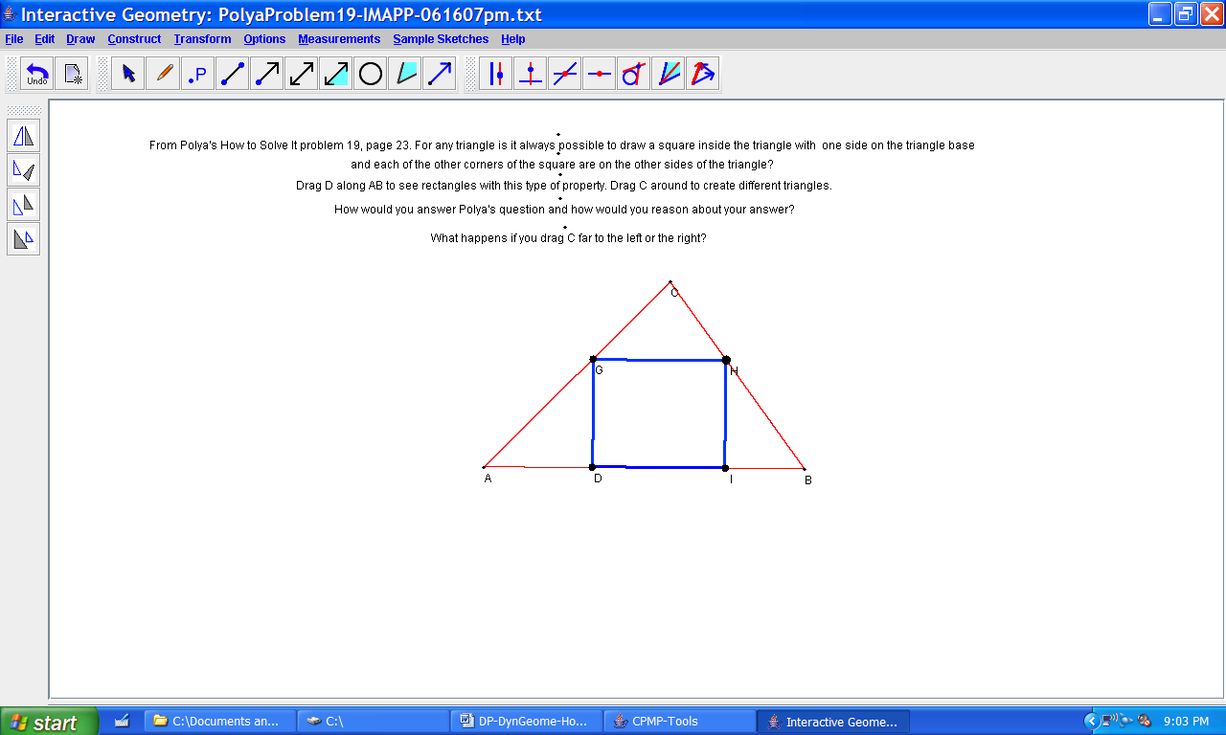

PART 2 -PLANE REFLECTIONS

Follow the workshop presenter's instructions to open the CPMPTools file called Tringl2LinesThru0Coord060707.txt

(through the Geometry/CoordinateGeometry/File/Open menus). You will see the graphic shown below. Next steps are written below the graphic and will be detailed by the workshop presenter. We are taking a very basic approach and assuming that some in the audience might not have had experience working in a computer dynamic geometry setting. So we include details of how to do geometric operations and constructions in the CPMPTools environment. If you are familiar with this type of environment, for example if you have used Geometer's Sketchpad or Cabri you may want to skip ahead to some of the questions posed below.

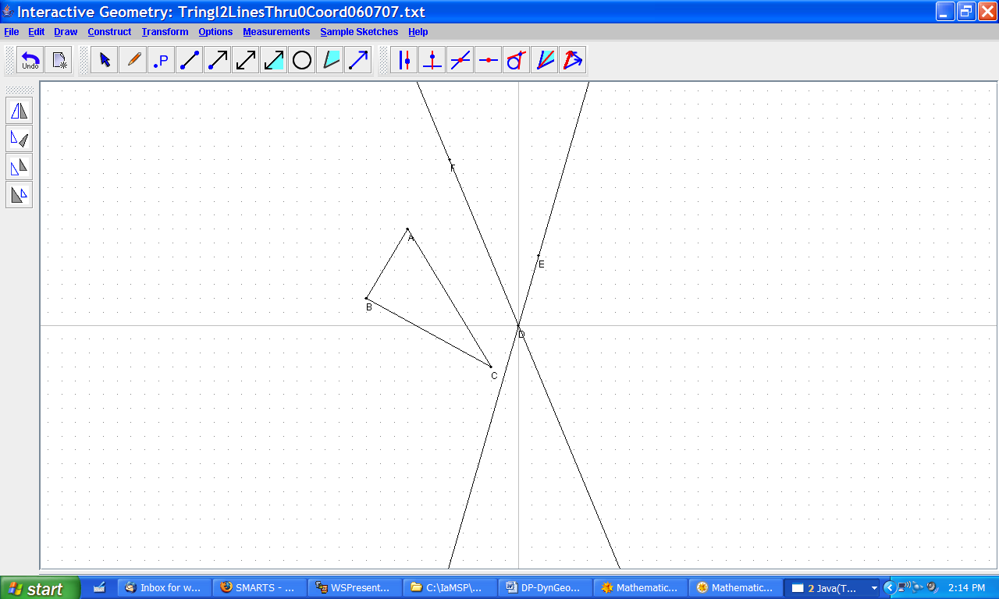

Instructions for how to manipulate the objects in this 'dynamic geometry' setting are given in the box below.

How to reflect triangle ABC across the line containing points D and E.

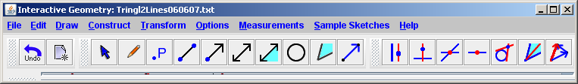

Under the word Construct, there is a blue arrow with black border. This arrow is called is called the "Selection Tool".

1. Click on the SelectionTool arrow to give your cursor the capability of 'selecting' object (by clicking on those objects).

2. Hold down the keyboard Shift key and click the mouse on segment AB. Doing this should turn that segment into a bold red segment.

Now while continuing to hold down the shift button, click on segment BC, then CA. Next click on the line containing the points D and E.
The result should look like the graphic below

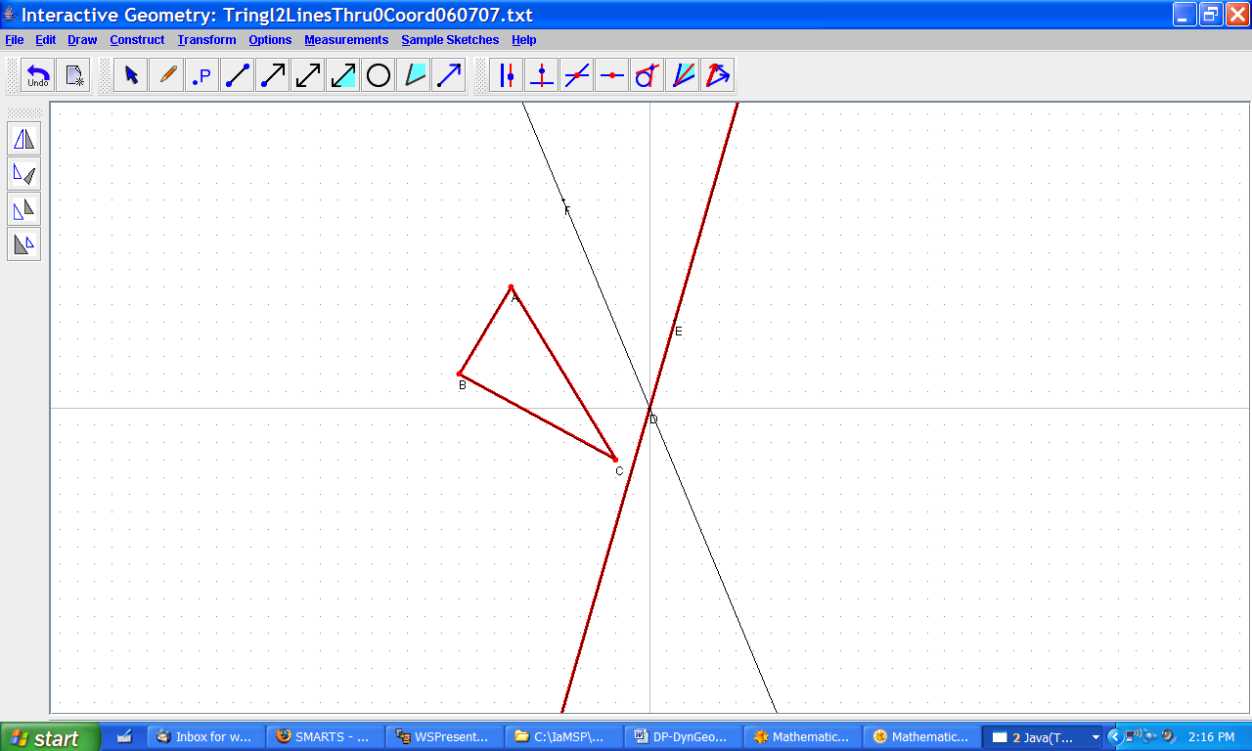

3. Now you can reflect triangle ABC across the line containing points D and E either by choosing the menu options: Transform/Reflect
or by clicking on the icon with two 'facing' triangles at the top of the four vertical buttons on the left side of the screen:

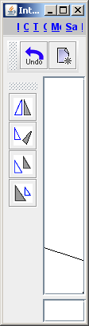

Choose one of these options to reflect the triangle ABC across the line containing the points D and E. You should end up with new triangle with vertices A', B', C'.
You can move around the line by Selecting one of the points D or E on that line, holding down the mouse button, and moving the mouse.
As the line moves, so does the reflected image of the triangle!

Questions:
Q1. -Reflecting across these two lines

Repeat this process with the newly reflected triangle A' B' C' across the across the line containing the points F and G. You should end up with third triangle with vertices A'', B'', C''.

How are triangles A B C and A'' B'' C''. Related? Is there one plane transformation (reflection, rotation or translation) which would change A B C and A'' B'' C'' in just one step?

Q2. -Reflecting across different lines

You can move around either of the two lines by Selecting one of the points on that line, holding down the mouse button, and moving the mouse. What happens to the reflected triangles when you move one of the two lines? They probably move around (this is what is meant by "Dynamic" geometry, that you can move things around). Do the ways the triangles move give any ideas about how reflecting across one or two lines is related to other plane transformations?

Q3. -Reflecting across parallel lines

Open a new copy of Tringl2Lines060607.txt . Using the selection tool, choose the line containing the points F and G, and delete this line by hitting either the Delete button or the backspace button on your keyboard (you can also delete the points F and G by selecting each one then hitting delete).

Now construct a line parallel to the line containing points D and E by following the instructions in the box below.

1. Click on the menu button labeled with a "P" (DrawPoint(s)), under the word Transform. This choice will make clicking the mouse produce points on the screen.

2. Click anywhere on the screen except on the line containing points D and E. This will cause a new point to be created.

3. Click on the SelectionTool arrow (under the word Construct). Then hold down the shift key and select the line and newly created point.

4. Click on the ConstructParallelLine button under the word Help.

Now you should have a new line parallel to the line containing points D and E.

If you reflect triangle ABC across one of these two parallel lines, yielding a new triangle A' B' C', then reflect the resulting triangle A' B' C' across the other parallel line, what do you get for this third triangle A'' B'' C''?

How are triangles A B C and A'' B'' C''. Related? Is there one plane transformation (reflection, rotation, translation or glide reflection) which would change A B C and A'' B'' C'' in just one step?

